Q1. Write a java program to swap two numbers without using variable.

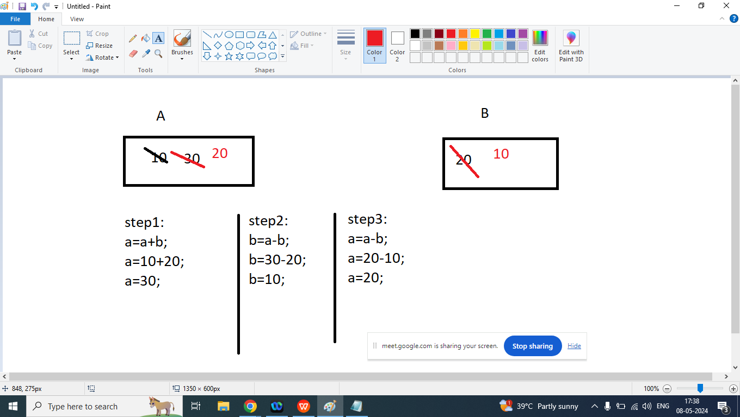

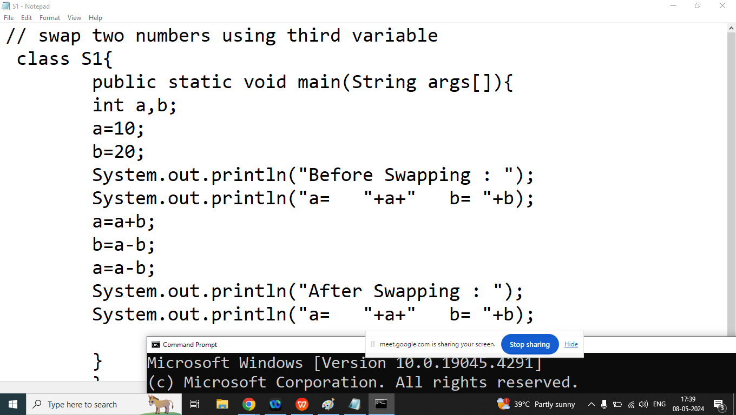

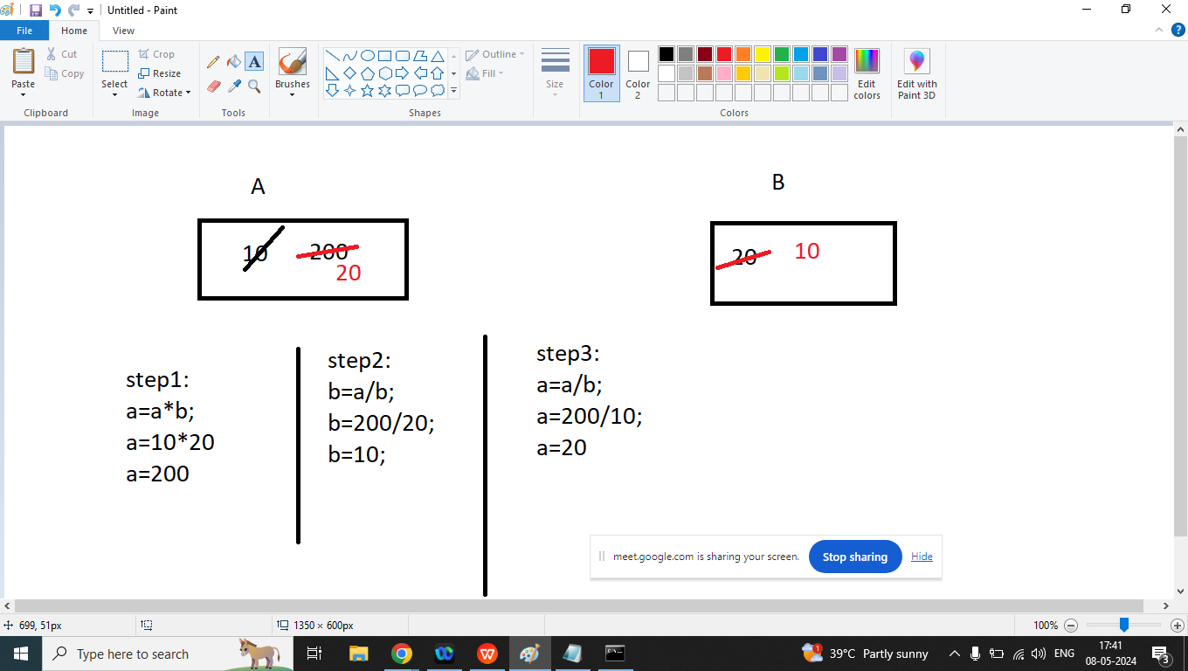

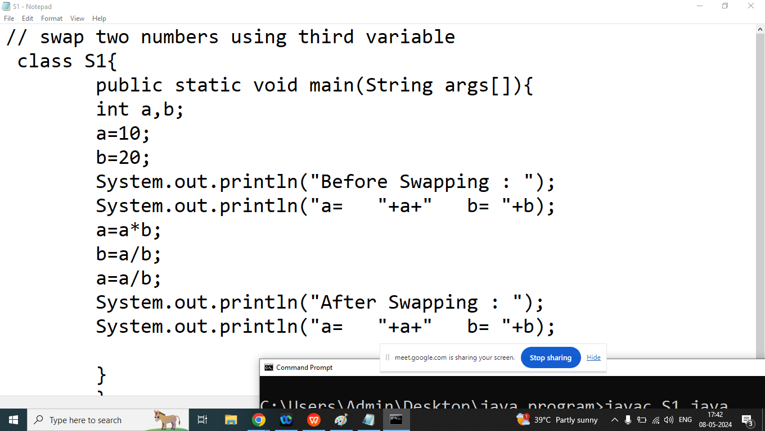

Q1. Explain Operators in java programming?

Ans: Operators are symbols that tells to the compiler to perform some specific task

Example:

C=10+20;

In above expression =,+ are operators and C,10,20 are operators

Types of Operators on the basis of Number of Operand

1. Unary Operator: It takes only one operand at a time and perform some specific operations

Example: i++,!,~,

1. Binary operators: It takes two operand at a time and perform some operations

Example: >,<,==, +,-,\*,/,%

1. Ternary Operator: It Takes three operand at a time and perform some specifc operation

Example: exp1 ? exp2: exp3;

Types of Operators on the basis of functionalities

1. Arithmetic operators[+,-,\*,/,%,++,--]
2. Relational Operators[>,<,>=,<=,==,!=]
3. Logical Operators [&&,||,!]
4. Bitwise Operators[&,|,~,<<,>>,^]
5. Conditional Operators/ Ternary Operators[? : ]
6. Assignment Operators[=,+=,-=,\*=,/=]

Operator Precedence

Operator Associativity

Q3.Explain Modulo operator in java programming?

Ans: if we want to find reminder of any number then we should go for module operator

Modulo(%)

First Operand % Second Operand

Example:

10%3====>1

35%4====>3

4%10====>4

Note: in case of modulo operator if first operand is less than second operand then reminder will be first operand

Division (/)

First Operand / Second Operand

Example:

10/3=====>3

35/4=====>8

4/10=====>0

Q4. Write a java program to print last digit of the given number

Enter Any Number : 123

Last digit of the number: 3

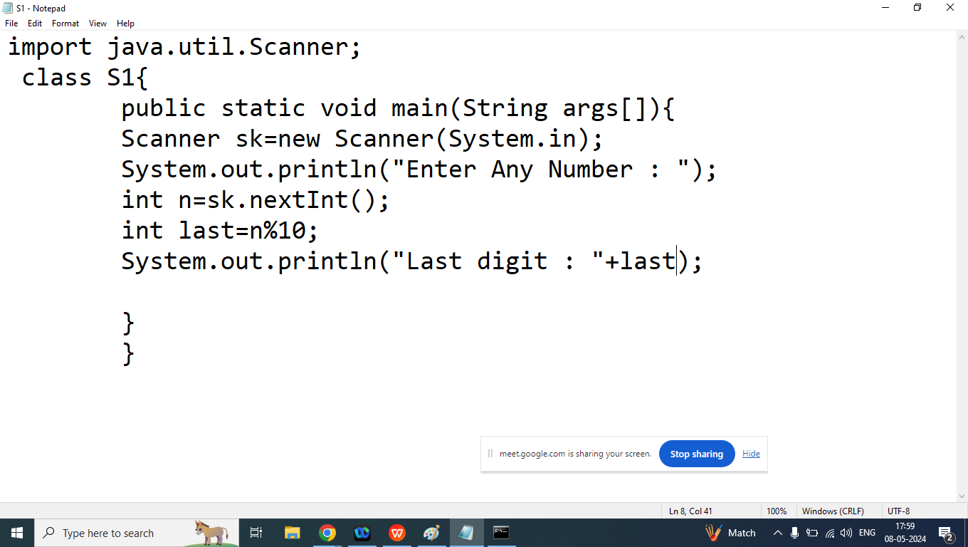

Homework:

Q1. Write a java program to print second last digit of the given number.

Enter Any Number : 1234

Second Last Digit of the given number : 3

Q2. Write a java program to convert given amount into smallest possible bank notes.

Enter Amount : 1388

Notes of 100: 13

Notes of 50 : 1

Notes of 20: 1

Notes of 10: 1

Notes of 5: 1

Notes of 2: 1

Notes of 1: 1